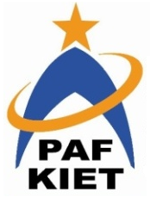
PAF-Karachi Institute of Economics & Technology
(The Center of Excellence)
College of Computing and Information Sciences
Software Engineering Course Project Proposal Form

Sno. | Stud. ID | Names | Course Name/CID
1 | 8860 | Ajmal Iqbal (Captain) | Software Engineering/106269
2 | 9061 | Muhammad Abdullah | Software Engineering/106269
3 | 9308 | Sameed Razi | Software Engineering/106269
4 | 9325 | Faiq Ahmed | Software Engineering/106269
5 | 9318 | Muhammad Yousuf

Project Title: Document Archive System

- Motivation:

There is absolutely no company on the face of the Earth that can make it through a day without viewing and sharing documents. That includes marketing brochures, project proposals, technical documents, HR guidelines, and training materials just to name a few.
The problem is that the more we create and rely on documents for work, the more critical it becomes to have systems in place to manage the documents across your company and storage of important old documents is a major headache for every organization. This is where a document archiving system comes in. Document archiving means putting information you no longer use regularly into secure storage for extended periods of time.

- Functional Features

Module 1: Login Authentication (Common for all members)
Module 2: User Registration (Muhammad Abdullah)
Module 3:Document Registration (Ajmal Iqbal)
Module 4: Document Encrypt and Decrypt (Sameed Razi)
Module 5: Department Registration (Faiq Ahmed)
Module 6: Log Maintaining (Muhammad Yousuf)

Expected Detail of all Modules to be covered by each Member

1- Muhammad Abdullah: Login + User Registration

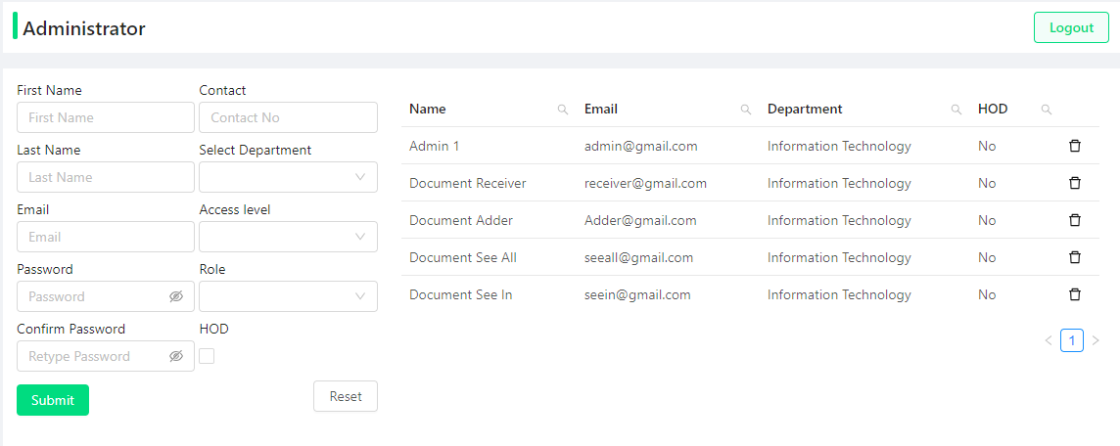

2- Ajmal Iqbal: Login + Document Registration

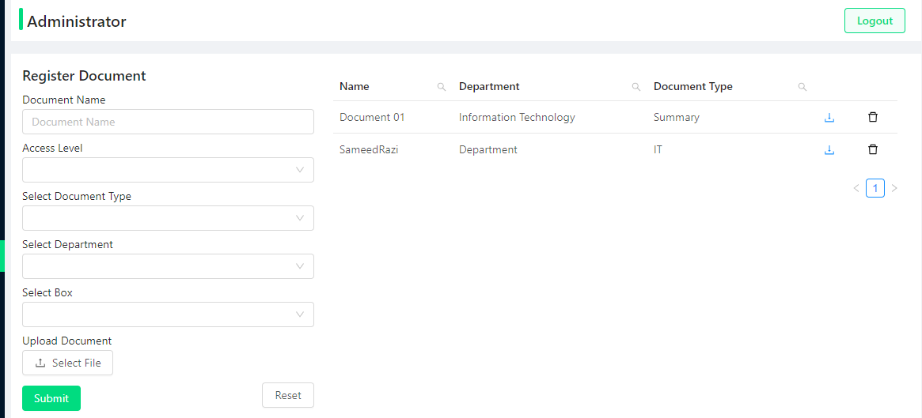

3- Sameed Razi: Login + Document Encrypt and Decrypt

When the File/Document is added in the system it is encrypted and when retrieved it is decrypted. The file in storage is unreachable because we are using AES algorithm with secret key that is always required to decrypt.

4- Faiq Ahmed: Login + Department Registration

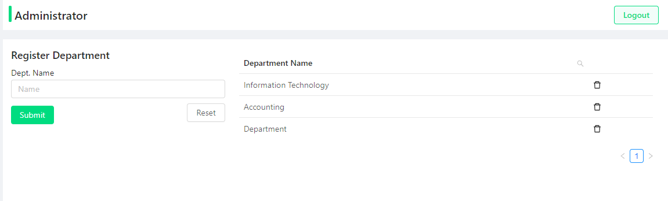

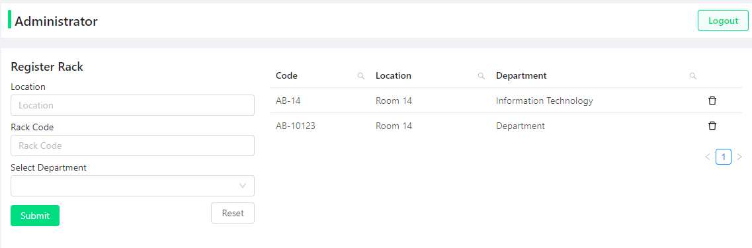

5- Muhammad Yousuf: Login + Log Maitaining

The software maintains log of all the users which are inserting and updating of all the models and this secures the software. This is in building phase ….

- Project Planning

This project is planned on Software Management Software Trello, please vist the bellow link for more details.
Gantt Chart trello Link

- Diagrammatic Representation of the Overall System


